Persian (Solar Hijri) Calendar
# Source: AI Source: Provided by: [Data Path: Persons Table -> ID Column: 1, Name_En Column: Motasem Essam] -> From: [ChatGPT] on [7/17/2026]
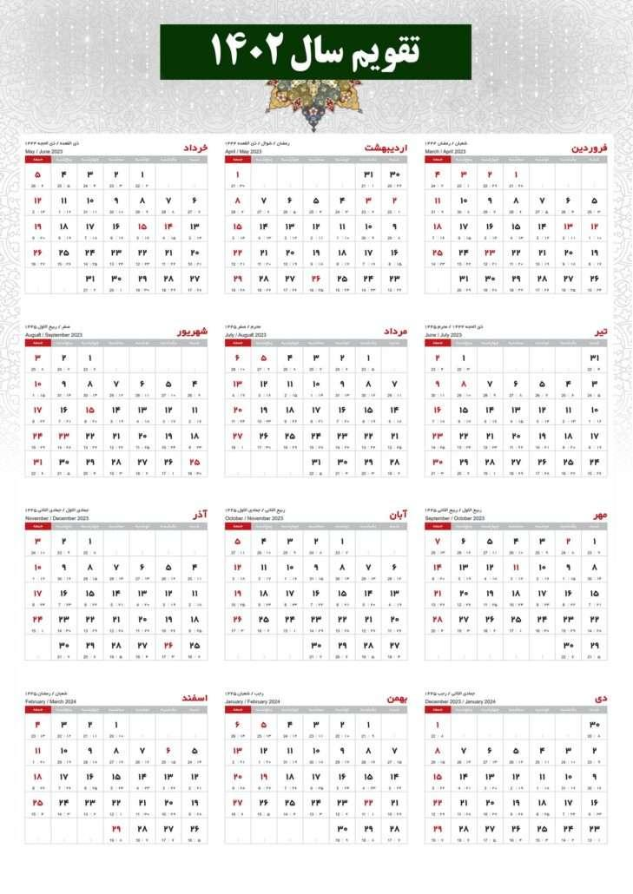
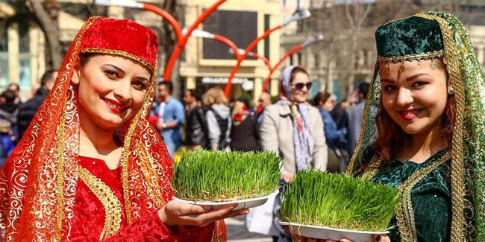
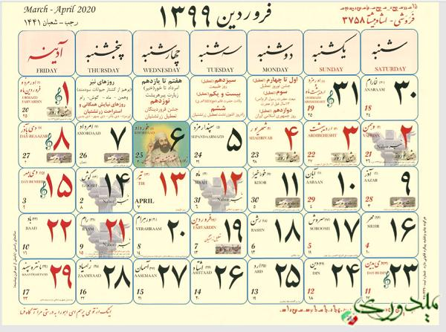
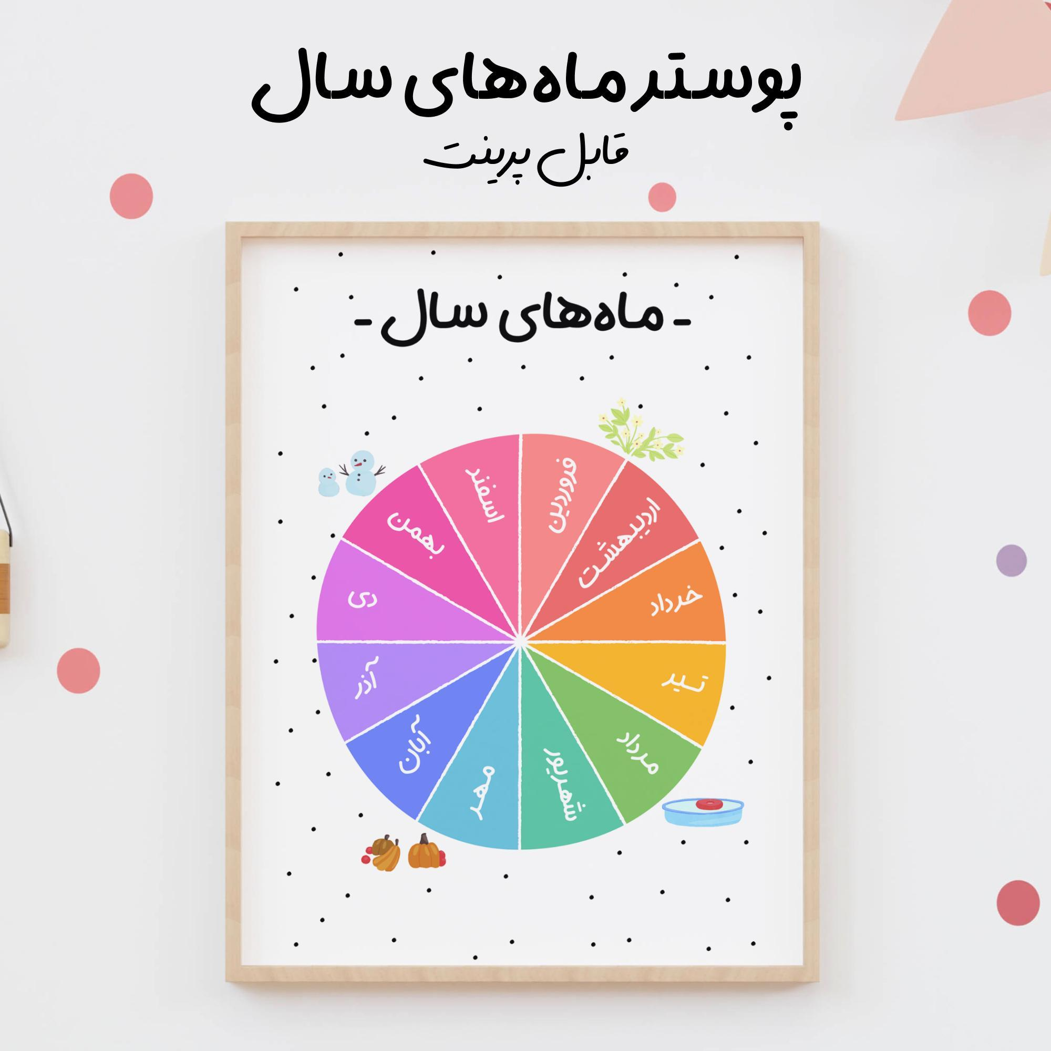
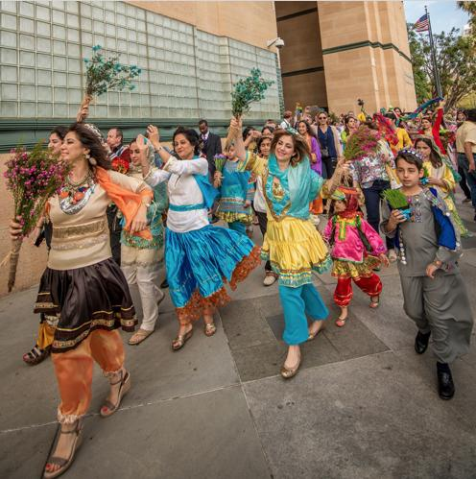
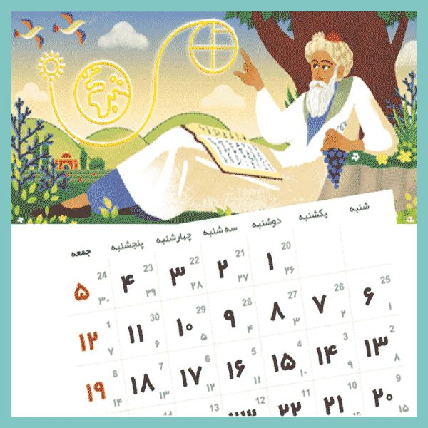
The Persian (Solar Hijri) Calendar, also known as the Iranian Calendar, is a solar calendar used officially in Iran and Afghanistan. It is widely regarded as one of the most accurate calendar systems in the world because it is based on the actual astronomical occurrence of the spring equinox rather than a fixed mathematical approximation.
Although it shares the term Hijri with the Islamic calendar because both count years from the Hijrah (migration) of the Prophet Muhammad in 622 CE, the Persian calendar is solar, while the Islamic (Hijri) calendar is lunar.

Definition
# Source: AI Source: Provided by: [Data Path: Persons Table -> ID Column: 1, Name_En Column: Motasem Essam] -> From: [ChatGPT] on [7/17/2026]
The Persian (Solar Hijri) Calendar is a solar calendar that begins at the astronomical spring equinox and counts years from the Hijrah of Prophet Muhammad in 622 CE.

Purpose
# Source: AI Source: Provided by: [Data Path: Persons Table -> ID Column: 1, Name_En Column: Motasem Essam] -> From: [ChatGPT] on [7/17/2026]
The Persian Calendar is used to:
- Measure civil dates.
- Organize government and business activities.
- Schedule education and public administration.
- Record historical events.
- Celebrate national holidays.
- Maintain accurate seasonal alignment.

History
# Source: AI Source: Provided by: [Data Path: Persons Table -> ID Column: 1, Name_En Column: Motasem Essam] -> From: [ChatGPT] on [7/17/2026]
Beginning of the Era
The calendar counts years from:
- Hijrah (Migration)
- 622 CE
Modern Form
The modern Solar Hijri Calendar was standardized during the 20th century and is now the official civil calendar of:
- Iran
- Afghanistan (with local variations)

Type of Calendar
# Source: AI Source: Provided by: [Data Path: Persons Table -> ID Column: 1, Name_En Column: Motasem Essam] -> From: [ChatGPT] on [7/17/2026]
The Persian Calendar is a:
- Solar Calendar
It is based on:
- The Earth's revolution around the Sun.
- The astronomical spring equinox.

Beginning of the Year
# Source: AI Source: Provided by: [Data Path: Persons Table -> ID Column: 1, Name_En Column: Motasem Essam] -> From: [ChatGPT] on [7/17/2026]
The Persian New Year begins on:
- Nowruz
Nowruz starts at the exact spring equinox, usually occurring on:
- 20 March
- 21 March
depending on the year and astronomical calculations.

Structure of the Calendar
# Source: AI Source: Provided by: [Data Path: Persons Table -> ID Column: 1, Name_En Column: Motasem Essam] -> From: [ChatGPT] on [7/17/2026]
The calendar contains:
- 12 months
- 365 days in a common year
- 366 days in a leap year

Months of the Persian Calendar
# Source: AI Source: Provided by: [Data Path: Persons Table -> ID Column: 1, Name_En Column: Motasem Essam] -> From: [ChatGPT] on [7/17/2026]
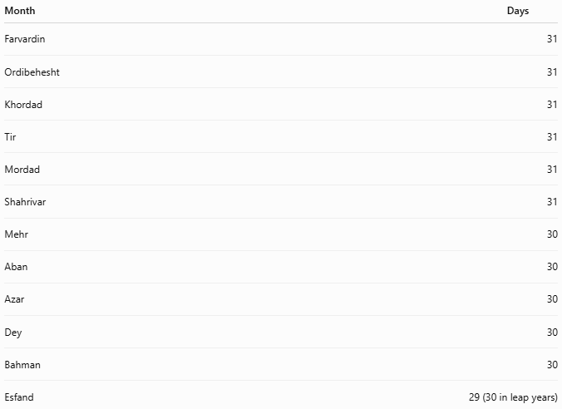
Month | Days
Farvardin | 31
Ordibehesht | 31
Khordad | 31
Tir | 31
Mordad | 31
Shahrivar | 31
Mehr | 30
Aban | 30
Azar | 30
Dey | 30
Bahman | 30
Esfand | 29 (30 in leap years)

Length of the Year
# Source: AI Source: Provided by: [Data Path: Persons Table -> ID Column: 1, Name_En Column: Motasem Essam] -> From: [ChatGPT] on [7/17/2026]
A common year contains:
- 365 days
A leap year contains:
- 366 days
Average length:
$$\boxed{365.2422\text{ days}}$$
This closely matches the actual tropical year, making the Persian Calendar extremely accurate.

Leap Year
# Source: AI Source: Provided by: [Data Path: Persons Table -> ID Column: 1, Name_En Column: Motasem Essam] -> From: [ChatGPT] on [7/17/2026]
Unlike the Gregorian Calendar, which uses a fixed mathematical rule, the Persian Calendar determines leap years based on astronomical observations and calculations tied to the spring equinox.
The additional day is added to:
- Esfand (the final month).

Accuracy
# Source: AI Source: Provided by: [Data Path: Persons Table -> ID Column: 1, Name_En Column: Motasem Essam] -> From: [ChatGPT] on [7/17/2026]
The Persian Calendar is considered one of the most accurate solar calendars because:
- The first day of the year is determined by the actual spring equinox.
- It stays closely synchronized with the seasons over very long periods.

Date Format
# Source: AI Source: Provided by: [Data Path: Persons Table -> ID Column: 1, Name_En Column: Motasem Essam] -> From: [ChatGPT] on [7/17/2026]
Common formats include:

Format | Example
DD/MM/YYYY | 01/01/1405
Day Month Year | 1 Farvardin 1405
YYYY/MM/DD | 1405/01/01

Major Events
# Source: AI Source: Provided by: [Data Path: Persons Table -> ID Column: 1, Name_En Column: Motasem Essam] -> From: [ChatGPT] on [7/17/2026]
The Persian Calendar determines the dates of:
- Nowruz (New Year)
- Sizdah Bedar
- National holidays in Iran
- Government schedules
- Educational calendars

Applications
# Source: AI Source: Provided by: [Data Path: Persons Table -> ID Column: 1, Name_En Column: Motasem Essam] -> From: [ChatGPT] on [7/17/2026]
The Persian Calendar is used in:
- Government
- Education
- Banking
- Business
- Legal documents
- National holidays
- Civil administration

Advantages
# Source: AI Source: Provided by: [Data Path: Persons Table -> ID Column: 1, Name_En Column: Motasem Essam] -> From: [ChatGPT] on [7/17/2026]
The Persian Calendar:
- Is highly accurate.
- Remains synchronized with the seasons.
- Uses an astronomical reference point.
- Has fixed month lengths that simplify planning.
- Provides stable agricultural and civil scheduling.

Limitations
# Source: AI Source: Provided by: [Data Path: Persons Table -> ID Column: 1, Name_En Column: Motasem Essam] -> From: [ChatGPT] on [7/17/2026]
The Persian Calendar:
- Is less commonly used internationally.
- Requires astronomical calculations for determining the exact start of the year.
- Is unfamiliar to many outside regions where it is officially used.

Comparison with Other Calendar Systems
# Source: AI Source: Provided by: [Data Path: Persons Table -> ID Column: 1, Name_En Column: Motasem Essam] -> From: [ChatGPT] on [7/17/2026]
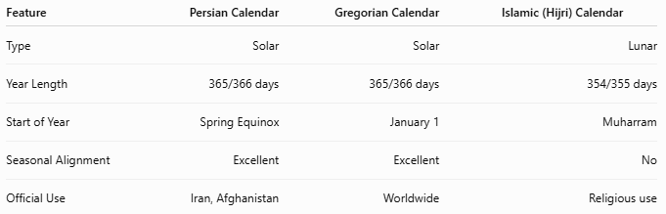
Feature | Persian Calendar | Gregorian Calendar | Islamic (Hijri) Calendar
Type | Solar | Solar | Lunar
Year Length | 365/366 days | 365/366 days | 354/355 days
Start of Year | Spring Equinox | January 1 | Muharram
Seasonal Alignment | Excellent | Excellent | No
Official Use | Iran, Afghanistan | Worldwide | Religious use

Common Mistakes
# Source: AI Source: Provided by: [Data Path: Persons Table -> ID Column: 1, Name_En Column: Motasem Essam] -> From: [ChatGPT] on [7/17/2026]
- Confusing the Solar Hijri Calendar with the Islamic (Hijri) Calendar.
- Assuming both calendars have the same months.
- Believing the Persian New Year always begins on the same Gregorian date (it depends on the exact equinox).
- Assuming leap years follow the Gregorian 4–100–400 rule.

Key Points
# Source: AI Source: Provided by: [Data Path: Persons Table -> ID Column: 1, Name_En Column: Motasem Essam] -> From: [ChatGPT] on [7/17/2026]
- The Persian (Solar Hijri) Calendar is a solar calendar.
- It begins with Nowruz, which starts at the astronomical spring equinox.
- It contains:
  - 12 months
  - 365 days in a common year
  - 366 days in a leap year
- The first 6 months have 31 days, the next 5 months have 30 days, and the final month has 29 or 30 days.
- It is the official civil calendar of Iran and Afghanistan.
- It is recognized as one of the most accurate calendar systems in use today.

Conclusion
# Source: AI Source: Provided by: [Data Path: Persons Table -> ID Column: 1, Name_En Column: Motasem Essam] -> From: [ChatGPT] on [7/17/2026]
The Persian (Solar Hijri) Calendar is a highly accurate solar calendar that measures time according to the Earth's revolution around the Sun and begins each year at the astronomical spring equinox. Although it shares its year numbering with the Hijrah of 622 CE, it differs fundamentally from the Islamic Hijri Calendar by maintaining close alignment with the seasons. Its precision, predictable month structure, and cultural significance make it the official civil calendar of Iran and Afghanistan and one of the most accurate calendar systems in the world.

